ICSB FY 2017-18 Incoming Officers |MINUTES
  - July 1st, 2017 | 2:00-5:00pm | UCA Buenos Aires, Argentina
Type of meeting Officers FY 2017-18  Facilitator Luca Iandoli (President)  Minutes taker Jordyn Murphy (Project Manager)  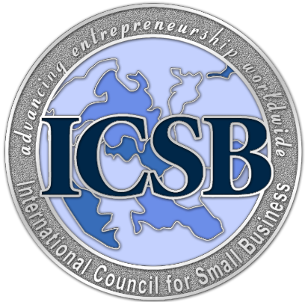 | Attendees  Voting Members  - Robert Lai (President)  -Luca Iandoli (Immediate Past-President)  -Geralyn Franklin (President-Elect)  - Winslow Sargeant (SVP, Development)  -Brian Gibson (WWF)  -Hermawan Kartajaya (ACSB President, Representative for Asia/Pacific)  -Ahmed Osman (MCSBE President, Representative from Europe/Middle East/Africa, SVP Finance and Control)  Non-Voting Members  George Solomon (Editor-in-Chief, JSBM)  J. Hanns Pichler (VP, Historian)  Jeffrey Alves (VP, Affiliate Development)  Olli Vuola (VP, ICSB 2019 W.C.)  Ayman Tarabishy (Executive Director)  Ki-Chan Kim (VP Human Entrepreneurship)

Agenda
2:00 | Call to Order– Luca Iandoli
2:00-2:05 | Approval of minutes from General Business Meeting in Hoboken, New Jersey
2:05-2:20 | 2016-2017 Year in Review – Luca Iandoli
2:20-2:30 | Presentation of President’s Award
2:30-2:45 | End of Year Financial Report and International Office Updates—Ayman Tarabishy
2:45-2:50 | Announcement of Election Results
2:50-3:00 | Remarks from President Robert Lai
3:00-3:05 | New Business

SUMMARY OF MOTIONS

[MOTION #1] MOTION: It was moved and seconded by Geralyn Franklin and Winslow Sargeant to approve the 2015-2016 minutes…Motion Passed

Discussion
  - Time allotted | 5 minutes | Agenda topic Approval of 2015-2016 Minutes | Presenter L. Iandoli
- Review of 2015-2016 AGM
- Geralyn Franklin motions to approve minutes

Motions
MOTION: It was moved and seconded by Geralyn Franklin and Winslow Sargeant to approve the 2015-2016 minutes …Motion Passed

  - Time allotted | 15 Minutes | Agenda topic 2016-2017 Year in Review | Presenter Luca Iandoli
- Resolution of MSME at the UN was a successful event for the ICSB
- 3 Strategy teams are created to push ICSB towards in 2030 goals
- The resolution will be celebrated every year at the UN, separate from June 27th
- The 3 different certificate programs are being launched this year
- The affiliate chapters are growing, with applications for Qatar, Jordan etc
- Thank you remarks
  - Time allotted | 15 minutes | Agenda topic Financial Reports| Presenter Ayman Tarabishy
- World Conference and MSME Day Fund have been added to the budget
- In good financial standing—made budget for affiliate fees, and exceeded JSBM Royalties
- Travel exceeds budget because of Ki-Chan Kim had to travel back from Korea to D.C

  - Time allotted | 5 minutes | Agenda topic Announcement of Election Results | Presenter Ayman Tarabishy
- President Elect Geralyn Franklin

Motions
None
  - Time allotted | 10 Minutes | Agenda topic Remarks from President Lai | Presenter Robert Lai
- Thank you remarks
- 2020 or 2030 strategy should be very clear for researchers, practitioners, and policy makers
- Work on continuing to build and support our affiliates
- Focus more on incorporating entrepreneurs and also local governments

  - Time allotted | 5 Minutes | Agenda topic New Business| Presenter Ayman Tarabishy
- Next Board meeting in Egypt in November

Motions
None

